RTL Innovate: Digital VLSI Hackfest
Documentation
TEAM: SS
Member: Shreeja Kashyap
Siddhant Raghuvanshi

- Problem Title
Design of a Timer with Preset Value and Alarm Trigger.
Explanation:
The objective of this project is to design a digital timer that starts counting from a user-defined (preset) value and triggers an alarm when it reaches zero (or a target value). This type of system is widely used in real-life applications like countdown timers, microwave ovens, alarm clocks, and industrial automation systems.
The challenge is to ensure accurate counting, proper loading of preset values, and reliable alarm triggering at the correct time.

- Logic Used
The system is designed using a counter-based approach:
- A preset register stores the initial value.
- A down counter begins counting when enabled.
- A clock signal drives the counting operation.
- When the counter reaches zero:
  - Counting stops
  - Alarm signal is activated
Key Logic:
- Load Signal → Loads preset value into counter
- Enable Signal → Starts counting
- Counter == 0 → Trigger alarm

- Block Diagram

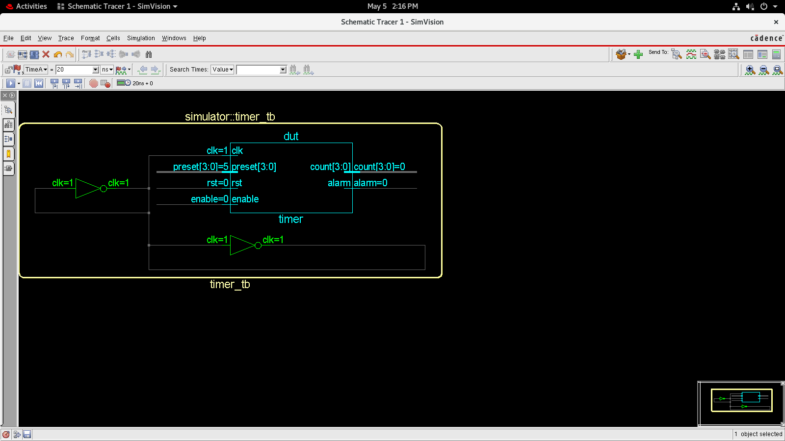
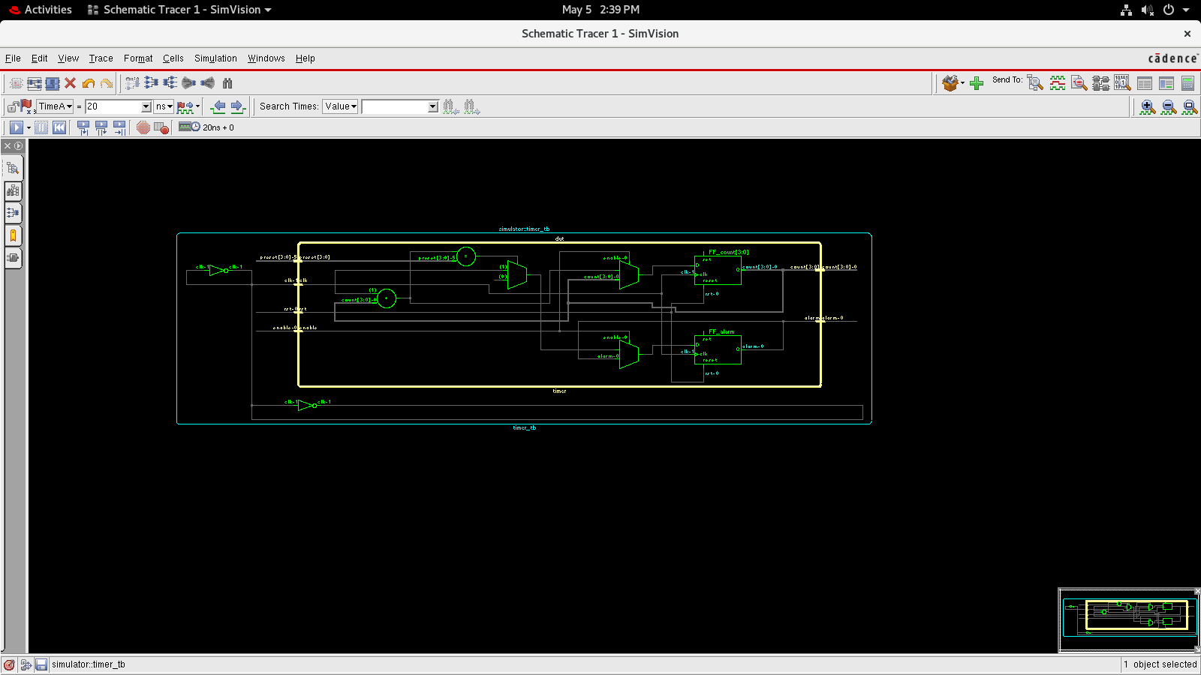

- Code Explanation
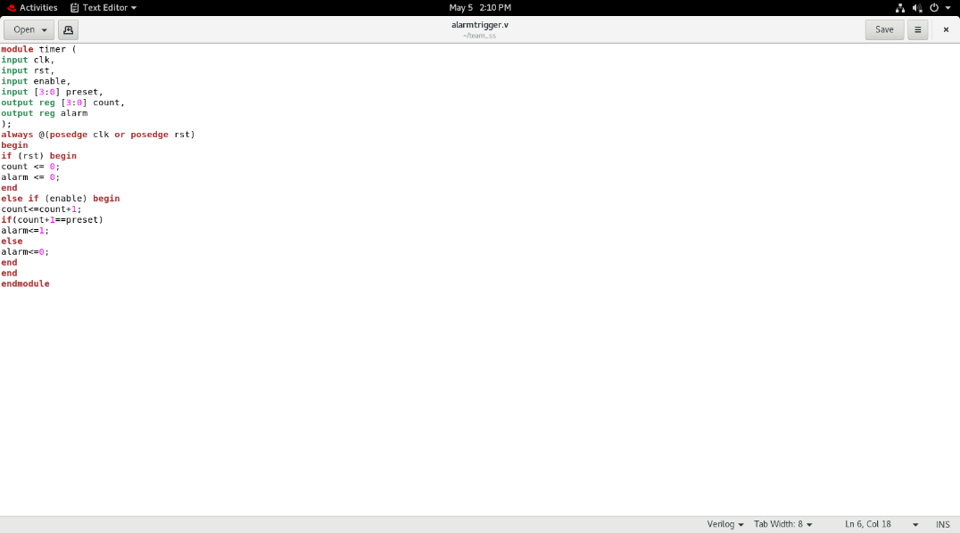
This Verilog code implements a 4-bit up-counter timer that increments its value on every rising edge of the clock when the enable signal is active. If the reset signal is high, both the counter and alarm are cleared to zero. During operation, the counter increases step by step, and the alarm signal is triggered when the counter is about to reach the preset value (checked using count + 1 == preset). This ensures the alarm goes high exactly when the desired count is achieved, making it a simple counter-based timer with a comparator-driven alarm output.
- Testbench Details
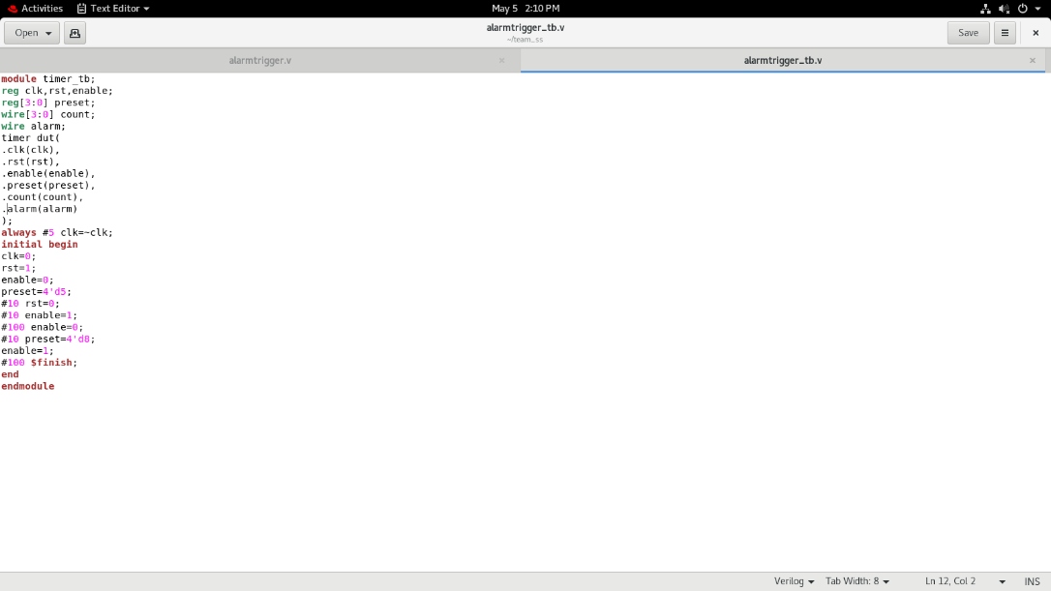
This testbench checks the timer by generating a clock signal and applying different input conditions. It first resets the system, then enables counting with a preset value and observes the counter and alarm outputs. After some time, counting is stopped, a new preset value is given, and counting resumes. The simulation ends using $finish, helping verify reset, counting, and alarm functionality.
- Waveform Analysis
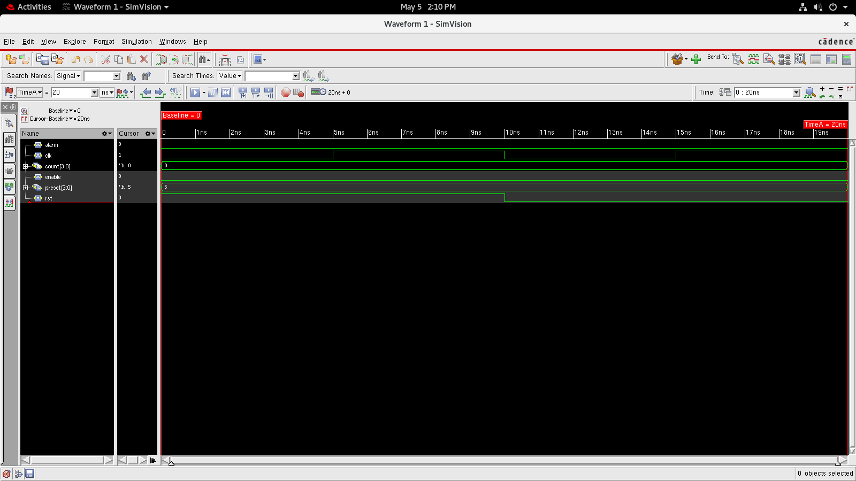
This waveform shows that when the reset is high, the counter is set to 0 and the alarm is low. After reset is removed and enable is high, the counter increments with each clock pulse. When the count reaches the preset value, the alarm goes high. When the enable is low, counting stops.

- Challenges Faced

- Synchronisation issues: Ensuring counter updates correctly on the clock edge.
- Handling reset and load priority: Needed proper condition ordering.
- Simulation timing errors: Adjusted clock period and delay.

- Applications

- Alarm clocks and digital timers.
- Traffic light control systems.
- Security systems (delay-based alarms).
- Embedded systems and microcontroller-based timing tasks.

